Title Title Title (Title Case)

(Thesis or Project) Keywords
Name, Name, Name (around 3)

A Project Proposal
Presented to the School of Industrial Design
Graduate Committee

By

Nicholas Economou
Master of Industrial Design Candidate 2025

In Partial Fulfillment of the
Requirements for the Degree
Master of Industrial Design in the
School of Industrial Design,
College of Architecture

Georgia Institute of Technology
April 2018

Primary Advisor
Name Name, School Name Name

Committee Members
Name Name, School Name Name
Name Name, School Name Name

Introduction
Type your introduction including background/literature review, purpose of the project/specific aims following the “5 stages” presented in class: research problem, short literature review, deficiencies “gap” in the literature, purpose of the study/specific aims, outcomes and significance of the study. Pictures may be included if necessary representing what cannot be explained with words.

Note: the entire document MUST use Arial 10, using bold for titles only. Subtitles may use italics.
The proposal is limited to minimum 6 pages and maximum 10 pages.

Introduction

Overview:
Our project aims to develop an AI-based assistive technology that enhances human sketching capabilities, specifically for product design conceptualization. By providing guidance and support through ethical decision-making processes, we aim to empower users to build their own personal datasets for refining their multimodal models while enhancing creativity and learning.

We present [SAS (Suggestive Ai Sketching)] that assists users to sketch interdependently through [scaffolding and discovery] as apposed to [following instructional guides and tutorials that are more structured and generic]. This tools is meant to support [product conceptualization to realization] with multimodal creativity support tools.

By using [suggestive feedback through predictive stroke analysis] this would in turn support human-authored product design conceptualizations, without having AI-based support taking over human leadership (AI-in-the-Loop~\cite{stanford} vs. Human-in-the-loop~\cite{bigham}).

This Project Study of [Assistive Sketching AI] provides [suggestive drawing strokes] for [design and prototyping] [for product design conceptualization], as well as [those still developing and advancing their sketching skills].

Research Problem:
We’ve identified the novel subject of treating AI Assistive Technologies as a pedagogical tool through personalized suggestive feedback for iterative sketching during the design process [Citation]. We analyzed how to communicate to users about [their next sketching stroke], under a variety of conditions.

The study focuses on enhancing an individual's sketching capabilities and to allow for the final outcome not directly be edited by Ai tools. The results could guide new individuals in navigating their own unique and personal approach to sketching.

We present a landscape analysis of commercially available Visual Assistance Technologies (VATs) that implement the use of recognizing and adjusting to match the users drawing style. We will also be looking into how the current market implements a pedagogical use of VATs and how they differ from our approach.

Methods:
Through literature review and keyword searches on the web and using AI models (e.g.,[CITE])/footnote), we have defined a conceptual framework that is backed by prior evidence in order to scope this project outcome. Through this process, we have identified three key themes of interest: sketching and learning (1) , pedagogical tools for creativity support and sketching (1), and assistive technologies and AI (1). These themes will direct the development of an AI tool that guides users in creating and refining their own sketches during the design process, without directly adding or subtracting from the final outcome. The study's results will provide valuable insights into how AI can be used as a supportive tool for human freehand drawing, thereby promoting user engagement and overall product design success

Literature Review:

Gaps in Literature:

Purpose and Aims:

Outcomes and Significance:

Methodology
Type your methodology here including methods, design process, participants, materials, procedures, etc answering methodology questions presented in class.

Methodological Map
Insert here a visual map of the thesis/project methodology.

Example:
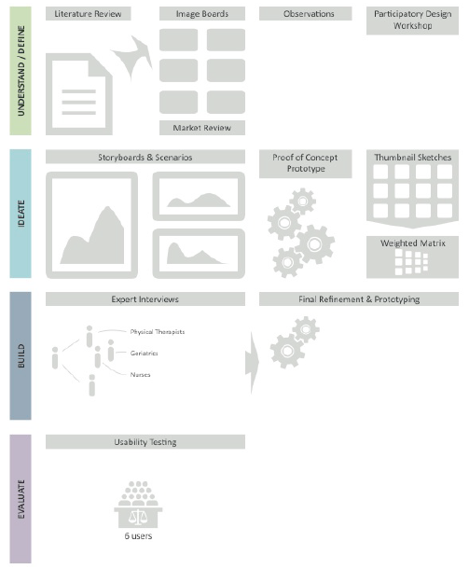

Timeline
Insert here a visual timeline of your thesis/project.

Example:

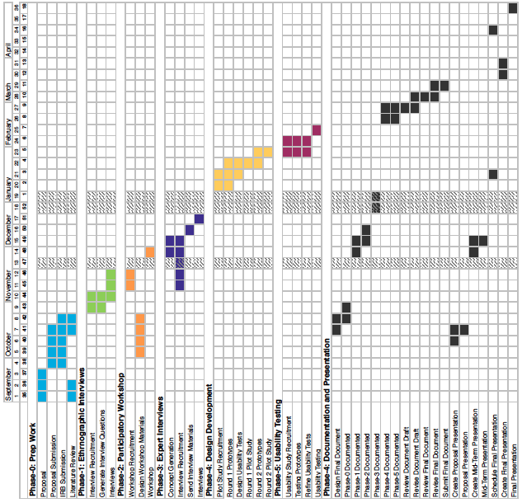

References
List all references used in this proposal following the APA 6th style (preferably).

Examples:

Book:
Author, A. A. (Year of publication). Title of work: Capital letter also for subtitle. Location: Publisher.

Journal Articles/Periodicals:
Author, A. A., Author, B. B., & Author, C. C. (Year). Title of article. Title of Periodical, volume number(issue number), pages. doi:http://dx.doi.org/xx.xxx/yyyyy

Website:
Author, A. A., & Author, B. B. (Date of publication). Title of document. Retrieved from http://Web address

Citation details:
http://owl.english.purdue.edu/owl/resource/560/1/

